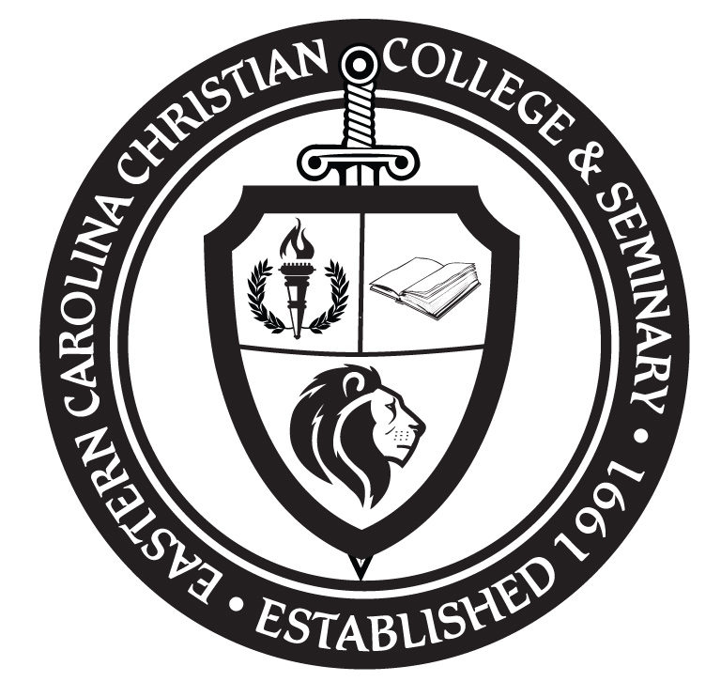 | Eastern Carolina Christian College & Seminary
 | 1015 Highway 48 South • P O Box. 1131 • Roanoke Rapids, NC 27870
Certificate of Woman in Leadership
ADVANCE
ADV 201 - Women in Leadership: Honors Seminar History seeks to understand and to explain the story of women in ministry experiences, since the past provides the only laboratory of human experience lived. Historical study compliments and builds on the foundational courses in the core through its appreciation of the complexity of women in ministry challenges, recognizing in the men and women who make history the intellectual, the material, social, and spiritual diversity of the human condition. History further advances the goals of the core curriculum through an interdisciplinary methodology that seeks to reconstruct our collective past.

ADV 202 - Women in Leadership: Giving and Receiving Feedback Research shows that feedback is critical for leaders and that creating a culture of feedback is key to a team's success. The more successful a team is, the better an organization's bottom line. However, there is an art to giving and receiving feedback, and if not done properly, feedback can have a negative impact to morale. Conversely, teams who receive feedback in a positive, supportive way will strive to continue to do well.

ADV 203 - Women in Leadership: Outsmart the Work-Life Balance To maintain energy and positive focus, it's critical for women in leadership roles to cultivate a healthy and productive balance between their professional and personal lives. In this course, the Professor examines the typical work-life balance conflicts that interfere with productivity and happiness. Students will also examine ways to create various checks to ensure they stay in balance, allowing them to move forward effectively and focus energy on the tasks that will have the greatest positive impact.

